Study Mini - Project Analysis Report

**Project Title**

Study Mini - All-in-One Student Productivity Web App

**Project Overview**

Study Mini is a comprehensive, browser-based productivity application designed specifically for students. It combines four essential study tools into a single, lightweight web application: a note-taking system, assignment tracker, weekly planner, and flashcard study tool. The application stores all data locally in the browser, making it instantly accessible without requiring accounts or internet connectivity after the initial load.

**Why Students Need This Application**

Students face multiple challenges in managing their academic workload:

- Information fragmentation across different apps and platforms

- Difficulty tracking assignments and deadlines

- Need for effective study tools like flashcards

- Lack of integrated planning systems

- Desire for simple, distraction-free tools

Study Mini addresses all these needs in a single, cohesive interface that's accessible from any device with a web browser.

**Key Benefits and Usefulness**

1. Centralized Organization: Combines multiple study tools in one place.

2. Accessibility: Works on any device with a web browser.

3. No Account Required: Uses local storage so students can start immediately.

4. Dark Mode Support: Reduces eye strain during late-night study sessions.

5. Responsive Design: Adapts to different screen sizes.

6. Data Privacy: All information remains on the user's device.

7. Simplicity: Intuitive interface without complex features.

Tools, Software, and Functions Used

**Technologies**

- HTML5: Provides the basic structure and semantic elements.

- CSS3: Handles styling, layout, and responsive design.

- JavaScript: Implements all interactive functionality.

- Local Storage: Browser-based data persistence (implied).

**Key Functions**

1. Theme Toggling: Dark/light mode switching via CSS custom properties.

2. Note Management: Create, store, and display text notes with titles.

3. Assignment Tracking: Add assignments with due dates and mark as complete.

4. Weekly Planning: Organize tasks by day of the week.

5. Flashcard System: Create question-answer pairs and study them.

6. Rendering Engine: Dynamically updates the UI based on application state.

**How the Study Mini Code Works - Brief Explanation**

The Study Mini application works through a combination of HTML structure, CSS styling, and JavaScript functionality:

HTML Structure

- Creates a responsive layout with four main sections (Notes, Assignments, Planner, Flashcards)

- Provides input fields and buttons for user interaction

- Includes a dark/light mode toggle

CSS Styling

- Uses CSS variables for theming (light and dark modes)

- Implements responsive design with Flexbox and CSS Grid

- Creates card-based UI with shadows and rounded corners

JavaScript Functionality

- Maintains application state in a single object (`state`)

- Uses a `render()` function to update the UI based on current state

- Implements event handlers for all user interactions:

- Adding new notes, assignments, planner tasks, and flashcards

- Toggling assignment completion status

- Cycling through flashcards in study mode

- Switching between light and dark themes

Data Persistence

- All data is stored in the browser's memory (resets on page refresh)

- The application could be extended to use localStorage for persistence

Key Functions

- el(id): Shortcut for document.getElementById

- render(): Updates all sections of the UI based on current state

- Event handlers: Handle user interactions and update state accordingly

The application follows a simple but effective pattern: user interactions update the state object, then the render function displays that state in the UI.

**Code Overview:**

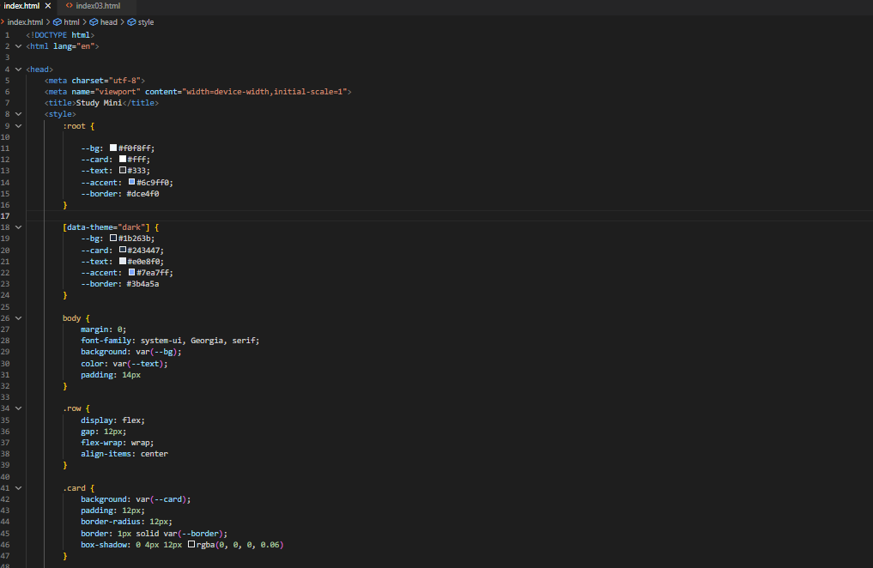

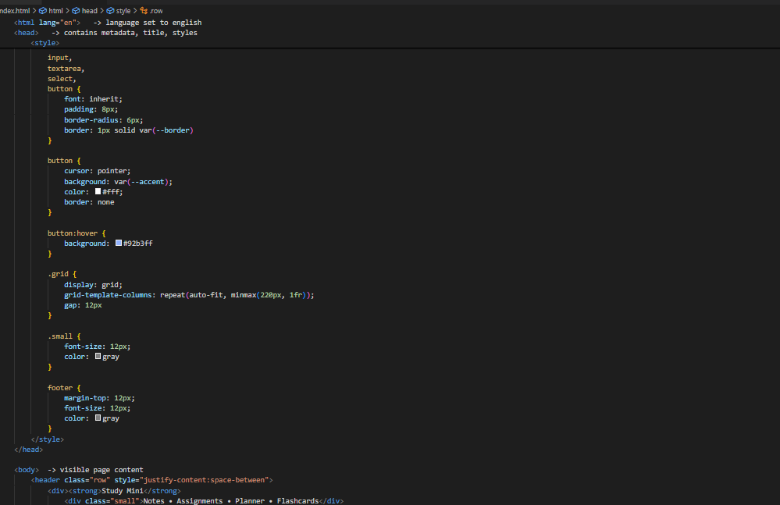

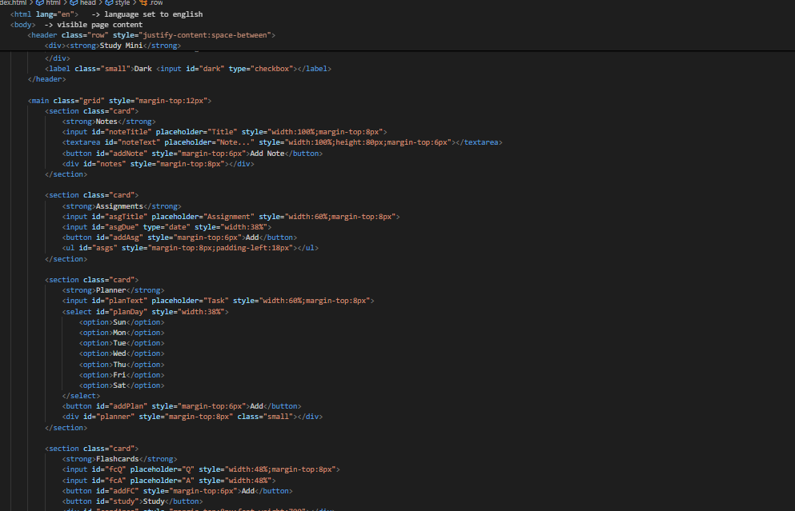

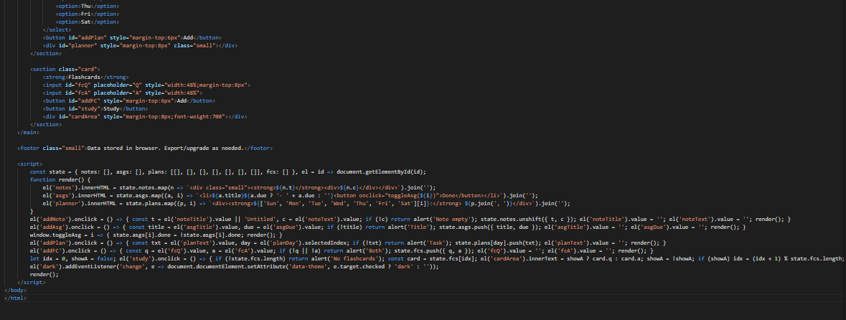

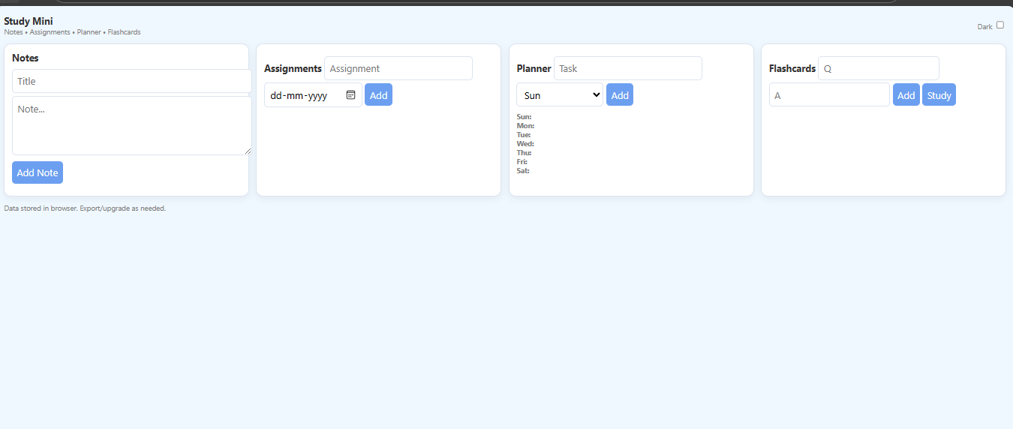**Result:**

**Conclusion**

Study Mini successfully delivers an integrated study assistance tool that addresses multiple student needs in a single, lightweight application. Its browser-based approach eliminates installation barriers, while its thoughtful design provides essential functionality without complexity. The application demonstrates effective use of modern web technologies to create a practical, user-focused tool that can genuinely enhance student productivity and organization.